|  |
| --- |
| School of Media Studies and IT |
| **Hackathon Team Management** |
| CPAN204 - Project |
|  |
| **Thuy Trang Khuc** |
| **Ferda Cetinoneri Ozel** |
| **12/7/2018** |

|  |
| --- |
| This is the CPAN204-Project2 which students design a web application using PHP/Python/MySQL |

Table of Contents

Section 1 : Analysis 2

Section 2: Database Design 3

Section 3 : Design Webforms 4

Section 4 : PHP codings 5

Section 5 : Python codings 6

Section 6: Program execution/output 7

Section 7: Project Feedback 8

# Section 1 : Analysis

For this project we were asked to design a web application using PHP/MySQL/Python for a Hackathon event which basically would collect user information and create specific size of user groups.

We discussed how we would meet the requirements. So, we broke the project up into tasks and decided on the tasks or sub-tasks each member is responsible for and also assigned due-dates for each task. Task list is divided as below:

* Ferda: Application main page, user registration, user login, user page that lists his/her group members, creating database
* Thuy: All admin functionalities (Admin login, create group, list/modify user info) and user file upload (text and excel)

At the end, we put all the pieces together, finalized the style and uploaded the project to webhost. The web address of the project is:

https://trangkthvsg.000webhostapp.com/

# Section 2: Database Design

Database tables, table fields and relationships are shown below.

Foreign keys on User_Group table have cascade(delete) constraint, so that when a group or user is deleted, related records on user_group are deleted automatically.

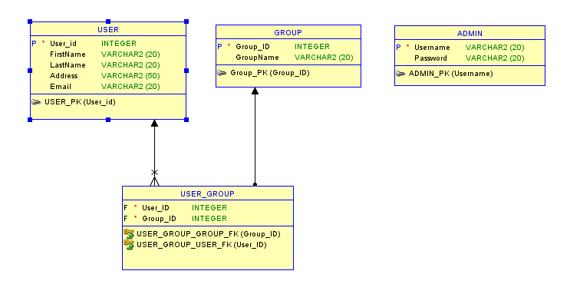

# Section 3 : Design Webforms

Main page of the web application:

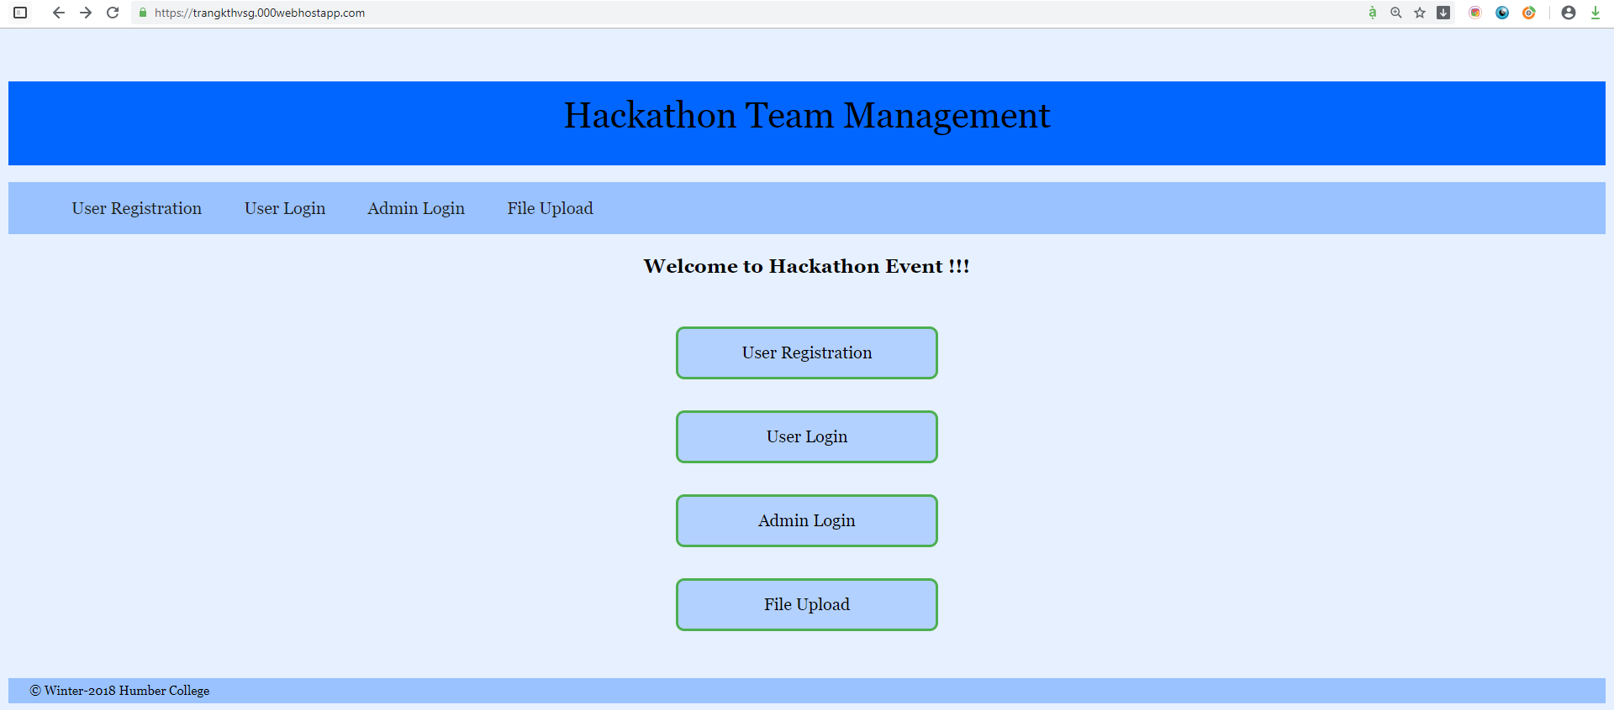

Registration of users

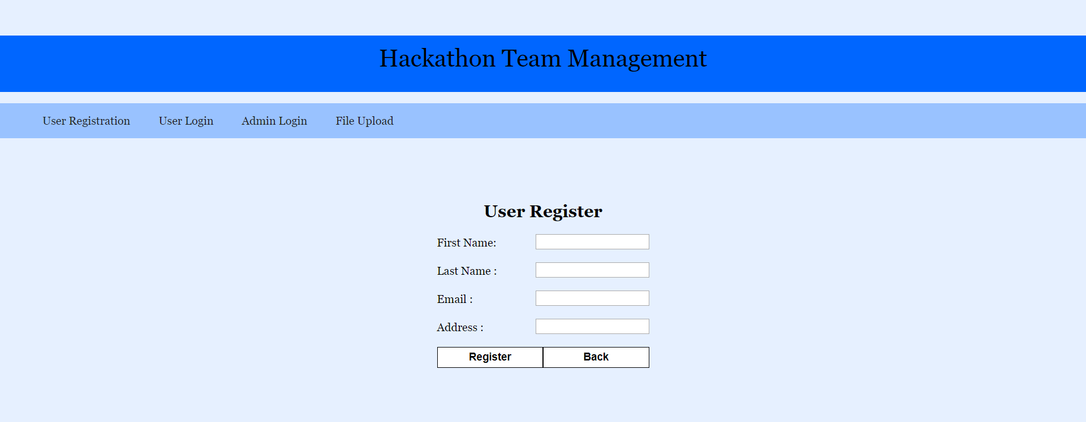

User login

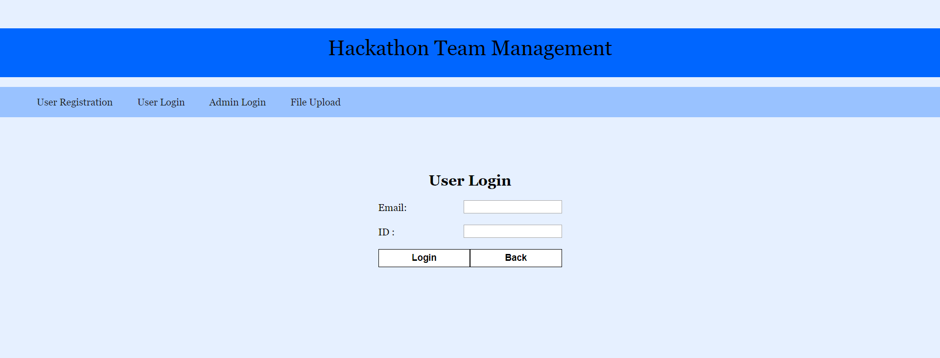

User page

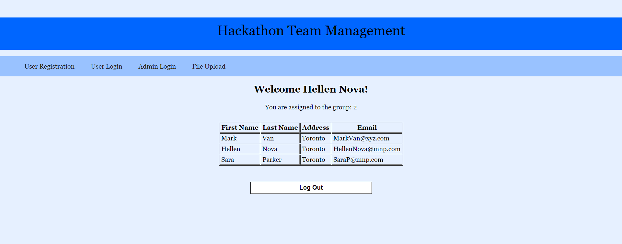

Admin Login

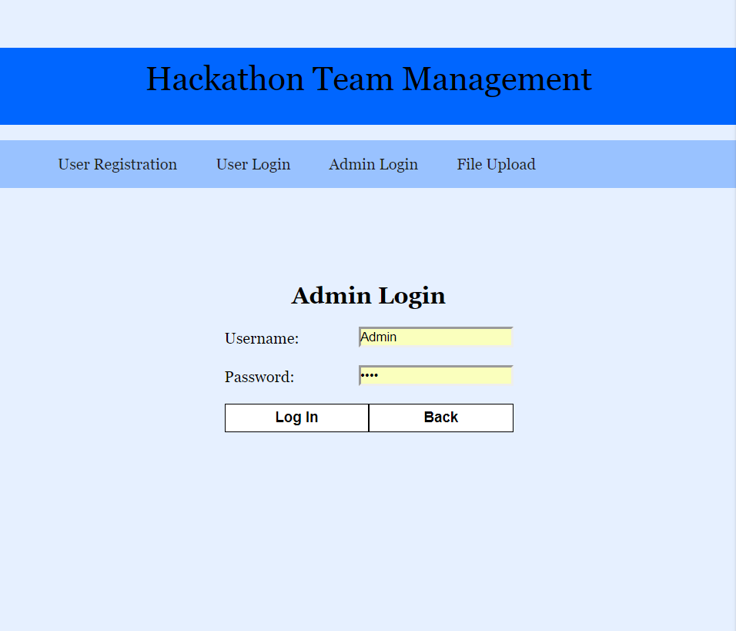

Admin menu

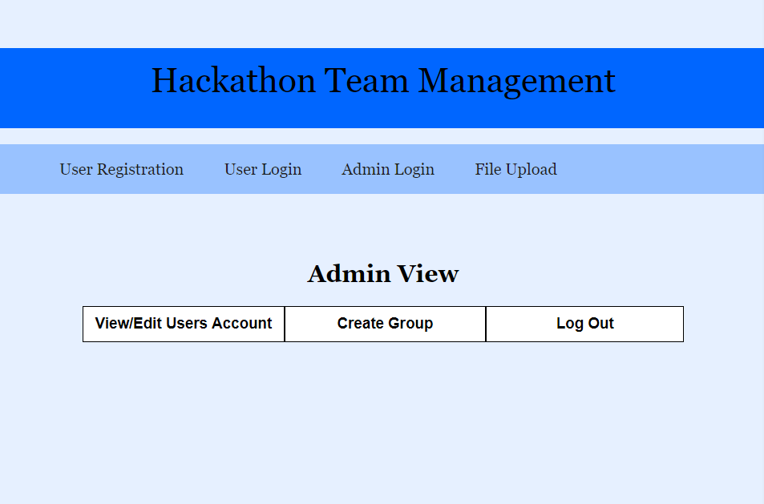

Admin view/edit/delete user information

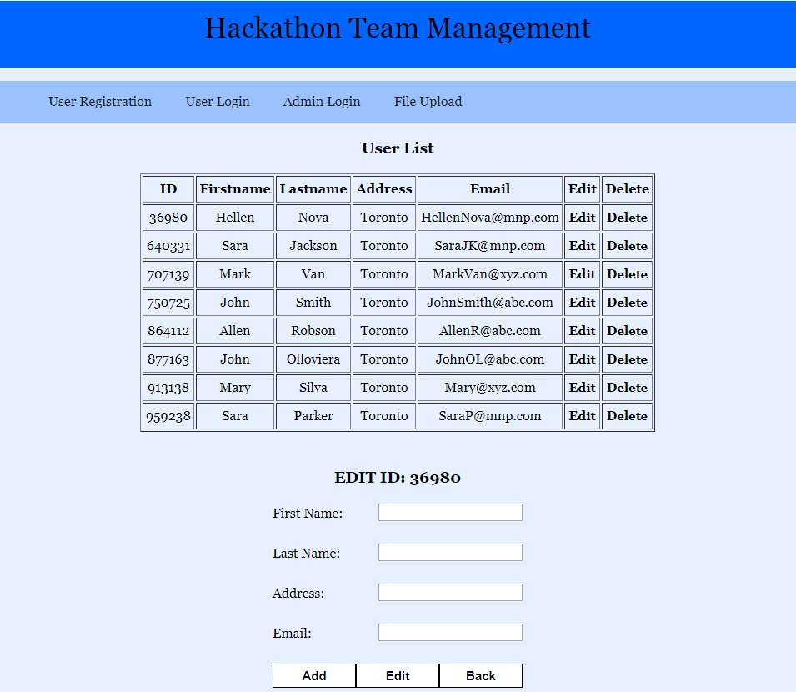

Admin create group

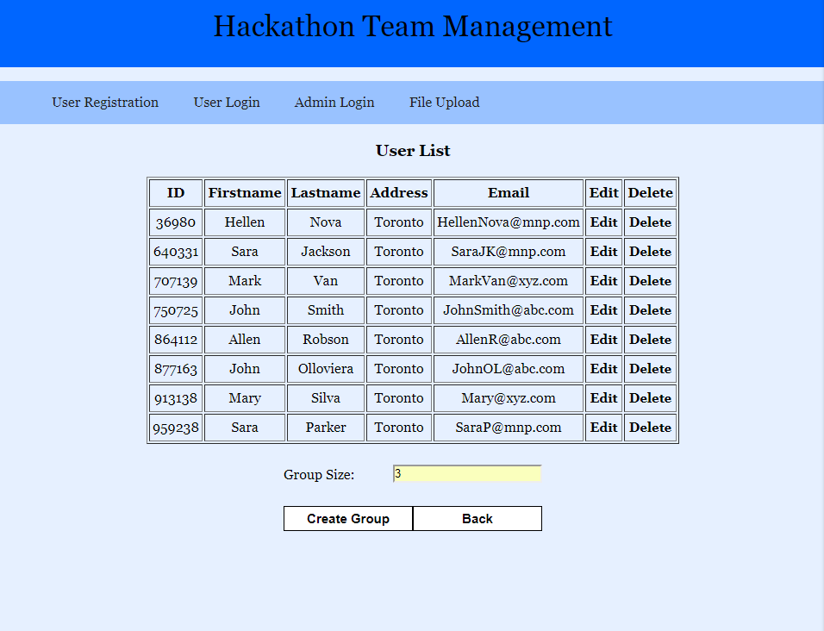

# Section 4 : PHP codings

**admin-login.php**: inputs username and pw, validates from database and if valid, directs to admin page.

**admin-portal.php**: directs admin to user management or group management pages.

**connect-db.php**: includes database connection commands.

**create-group.php:** lists users, inputs group size, creates groups and inserts group information into the database.

**delete.php:** deletes specified user from database.

**edit.php:** Updates user information.

**register-user.php:** takes user information, creates a unique user_id, and stores in database.

**user-login.php:** inputs email and user_id, validates from database, if valid, directs to user page.

**user-menu.php**: lists user information with delete/update options for admin.

**user-portal.php:** lists group information for user.

# Section 5 : Python codings

dataFile.txt

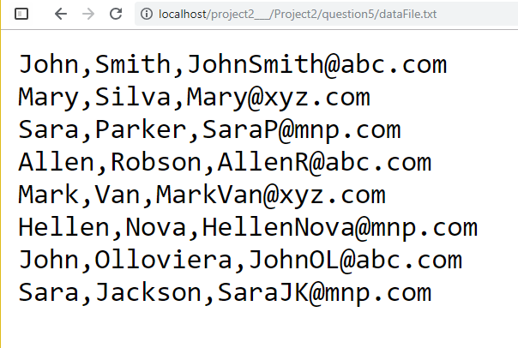

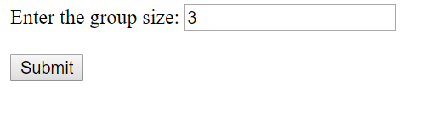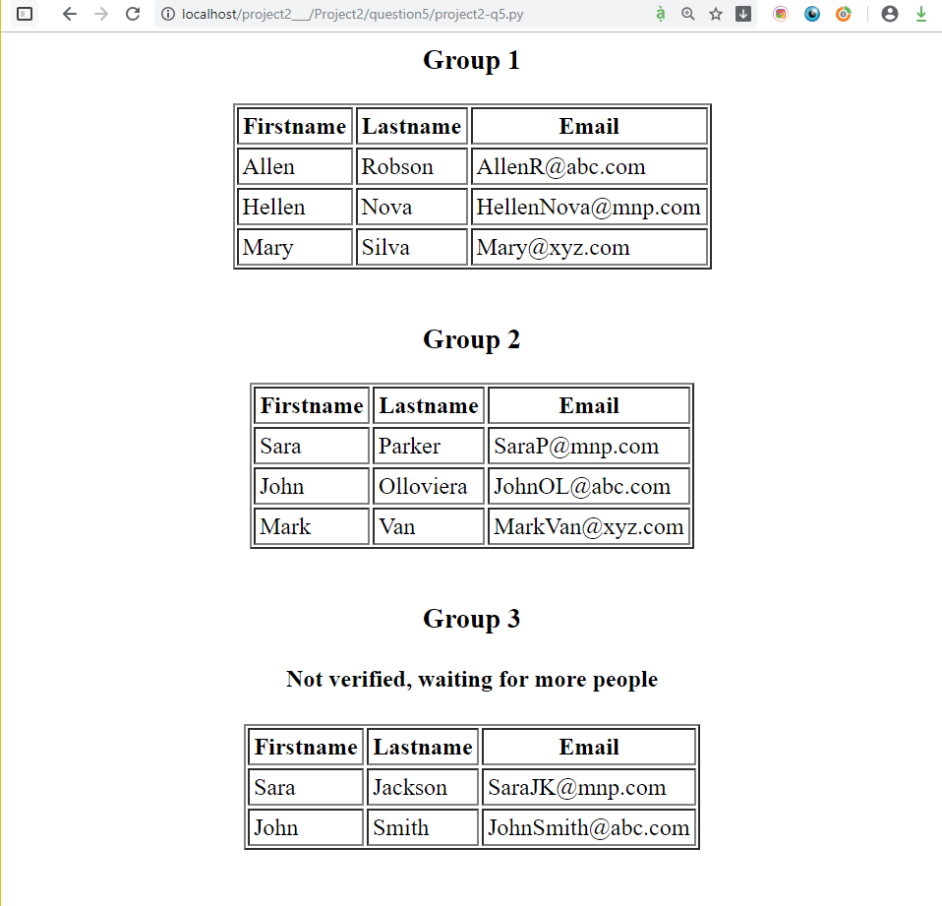

**Excel File:**

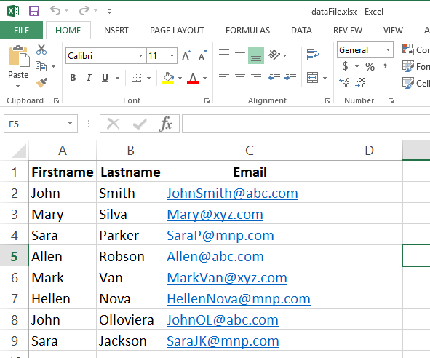

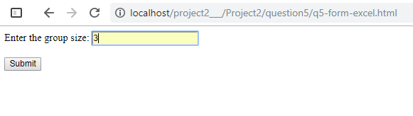

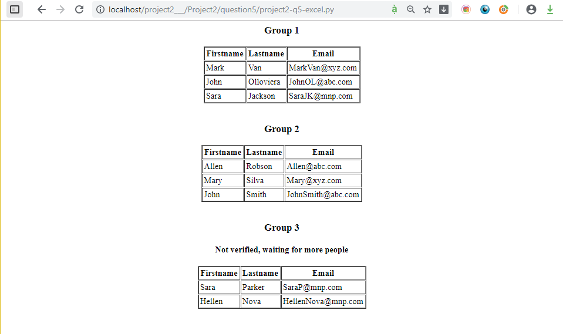

# Section 6: Program execution/output

User registration

|  |  |
| --- | --- |
|  |  |

User login

|  |  |
| --- | --- |
|  |  |

Admin login

|  |  |
| --- | --- |
|  |  |

View/Edit User Account

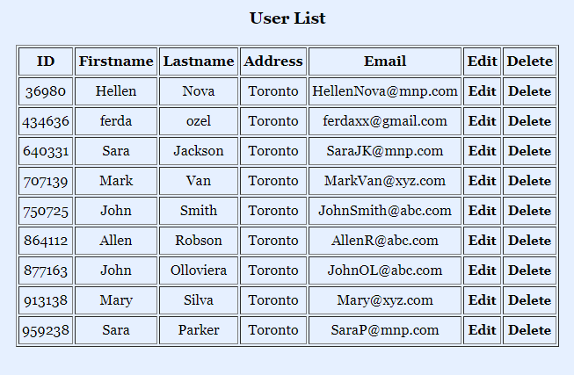

Edit :

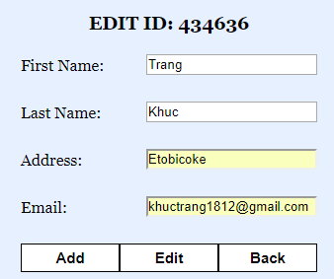

After updating user info

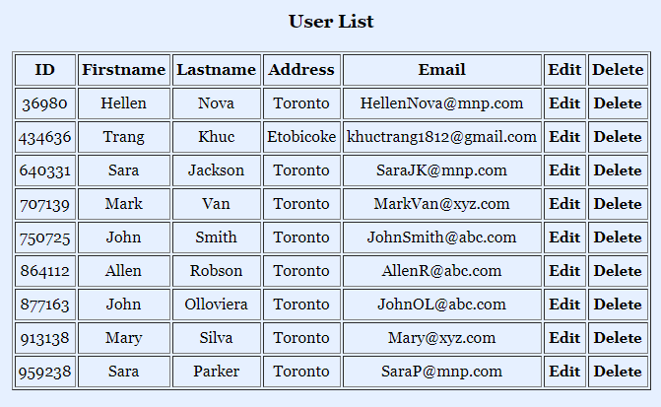

Adding new user

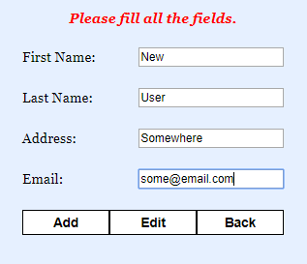

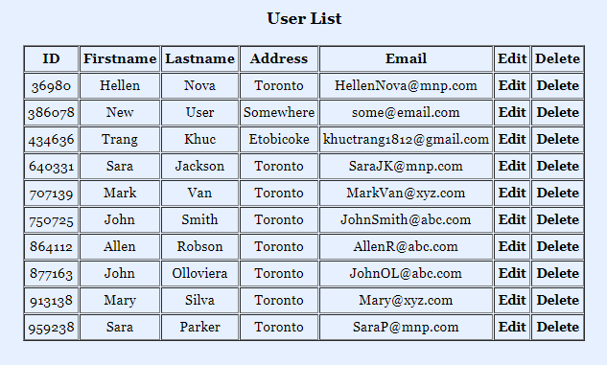

Create Group:

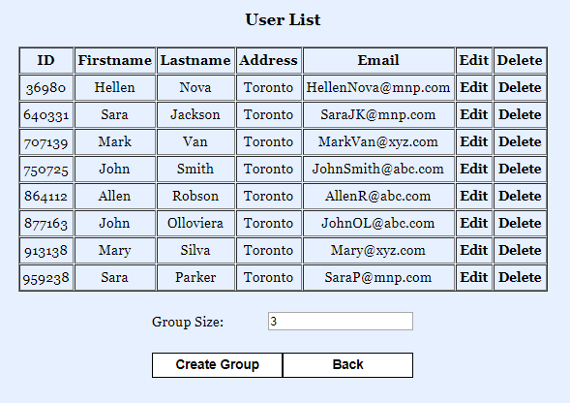

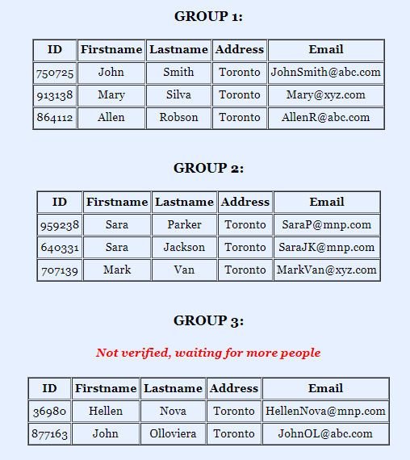

User login after group created:

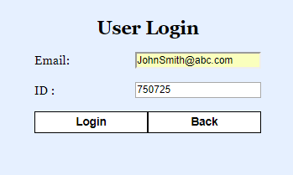

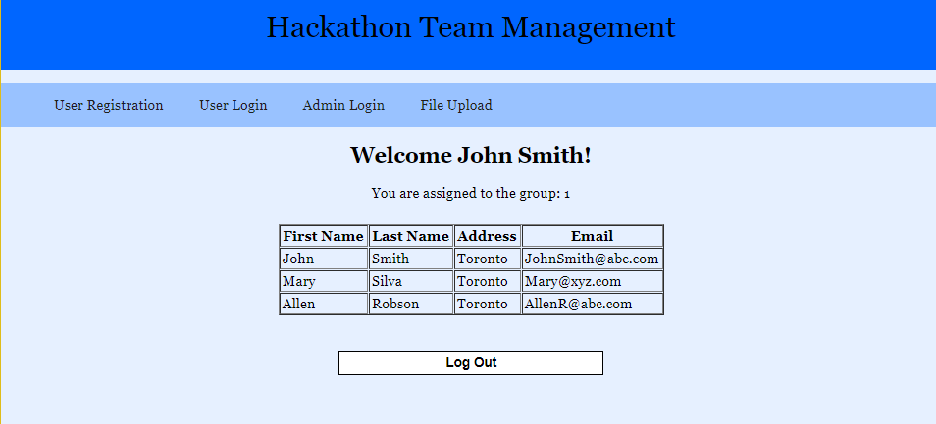

  

# Section 7: Project Feedback

Project was a good experience in terms of using what we have learned throughout this semester. Doing the project in group was also a good experience in terms of knowing each other and realizing others skills, and their perspective.

On the other hand, within such a limited time period, it is very difficult to do such a project with a group, because each group member has their own plans/schedule that may not fit to the other member. Communication and creating similar looking webpages in a limited time were also very challenging.